**Iteration 1**

Metrics Averaged

===========================

Avg Loss: 0.025694546240725015

Avg Mae: 0.07915871335487616

Avg Val_Loss: 0.00964015017655727

Avg Val_Mae: 0.06201445860298056

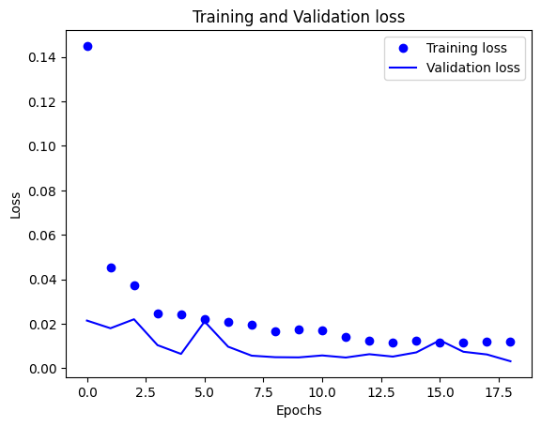

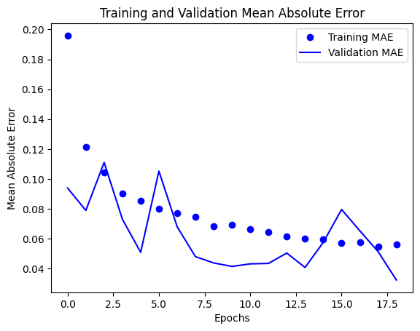

52/52 [==============================] - 0s 3ms/step - loss: 0.0025 - mae: 0.0311

Final Evaluation on Test Data

Loss: 0.0024852463975548744

Mae: 0.031134499236941338

149/149 [==============================] - 1s 3ms/step

50/50 [==============================] - 0s 2ms/step

Training RRMSE: 0.007366509846384506

Validation RRMSE: 0.011019674456073015

**Iteration 2**

Metrics Averaged

===========================

Avg Loss: 0.020844850753401888

Avg Mae: 0.06847204370745297

Avg Val_Loss: 0.007564065688899879

Avg Val_Mae: 0.04824276467592552

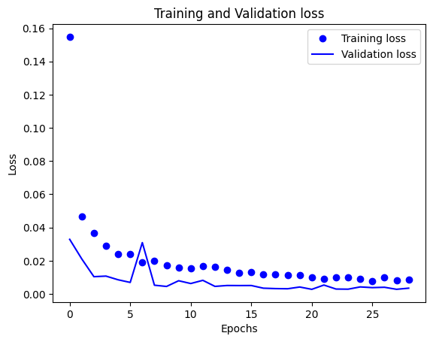

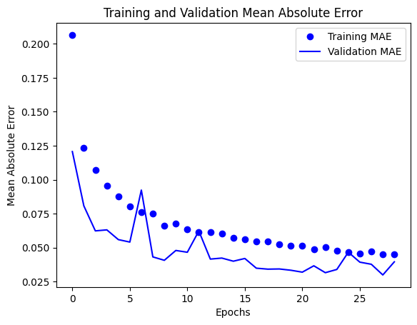

52/52 [==============================] - 0s 3ms/step - loss: 0.0033 - mae: 0.0417

Final Evaluation on Test Data

Loss: 0.003284237114712596

Mae: 0.041700806468725204

149/149 [==============================] - 1s 3ms/step

50/50 [==============================] - 0s 3ms/step

Training RRMSE: 0.006730544272017488

Validation RRMSE: 0.011545440913315743

**Iteration 3**

Metrics Averaged

===========================

Avg Loss: 0.014630054319277407

Avg Mae: 0.057241949141025546

Avg Val_Loss: 0.006818422472570092

Avg Val_Mae: 0.047361768186092376

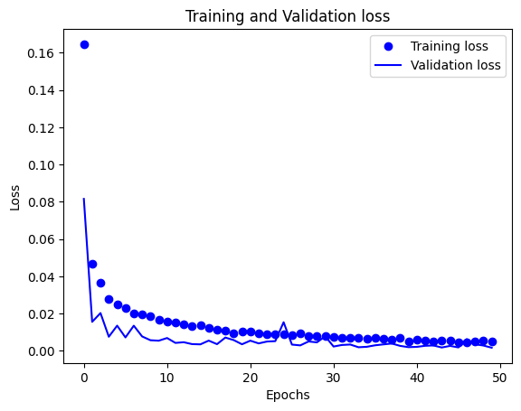

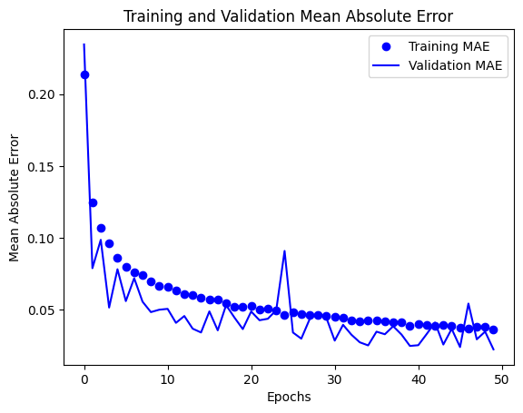

52/52 [==============================] - 0s 5ms/step - loss: 0.0015 - mae: 0.0234

Final Evaluation on Test Data

Loss: 0.0014603667659685016

Mae: 0.023436203598976135

149/149 [==============================] - 1s 3ms/step

50/50 [==============================] - 0s 3ms/step

Training RRMSE: 0.0053129915887132435

Validation RRMSE: 0.00802234269595986

**Iteration 4**

Metrics Averaged

===========================

Avg Loss: 0.03225211734668566

Avg Mae: 0.08768147831925979

Avg Val_Loss: 0.012750330918396894

Avg Val_Mae: 0.07124832931619424

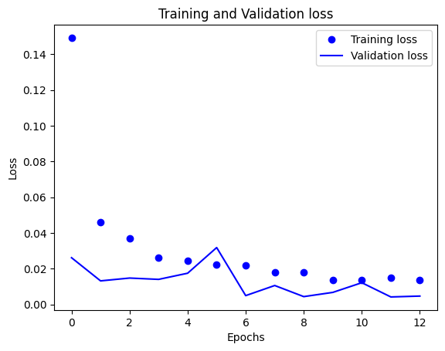

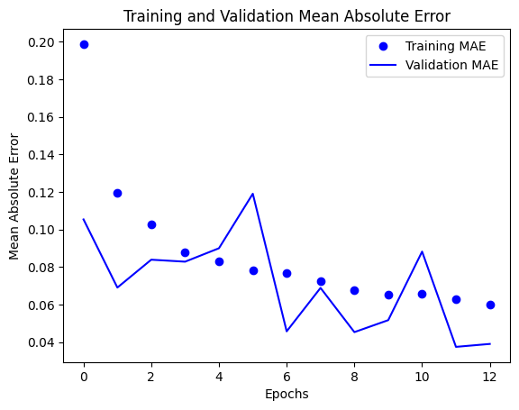

52/52 [==============================] - 0s 4ms/step - loss: 0.0039 - mae: 0.0390

Final Evaluation on Test Data

Loss: 0.0039174435660243034

Mae: 0.03901296854019165

149/149 [==============================] - 1s 3ms/step

50/50 [==============================] - 0s 3ms/step

Training RRMSE: 0.011594327404073944

Validation RRMSE: 0.013498971455315421

**Iteration 5**

Metrics Averaged

===========================

Avg Loss: 0.023365046484050928

Avg Mae: 0.07193511407132502

Avg Val_Loss: 0.007986078375122614

Avg Val_Mae: 0.05509106801063926

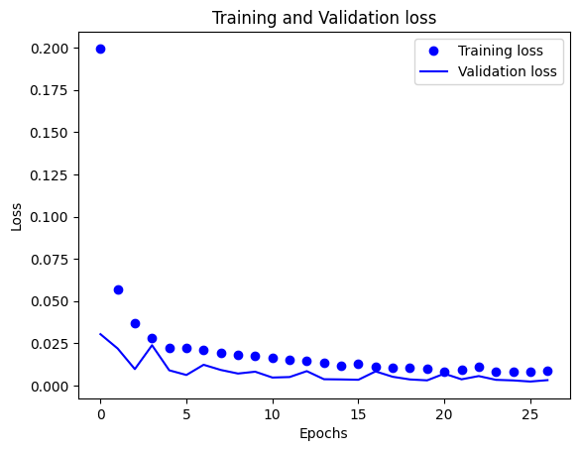

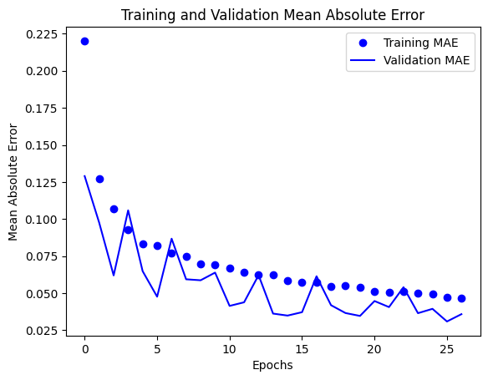

52/52 [==============================] - 0s 4ms/step - loss: 0.0037 - mae: 0.0379

Final Evaluation on Test Data

Loss: 0.003693303791806102

Mae: 0.03786224126815796

149/149 [==============================] - 1s 3ms/step

50/50 [==============================] - 0s 3ms/step

Training RRMSE: 0.00910368325517083

Validation RRMSE: 0.011099004207331455

**Iteration 6**

Metrics Averaged

===========================

Avg Loss: 0.022156712957299672

Avg Mae: 0.07170646308133236

Avg Val_Loss: 0.008274817078087766

Avg Val_Mae: 0.05500569323507639

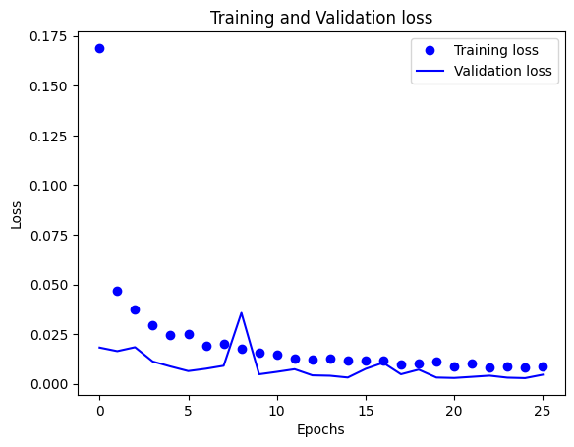

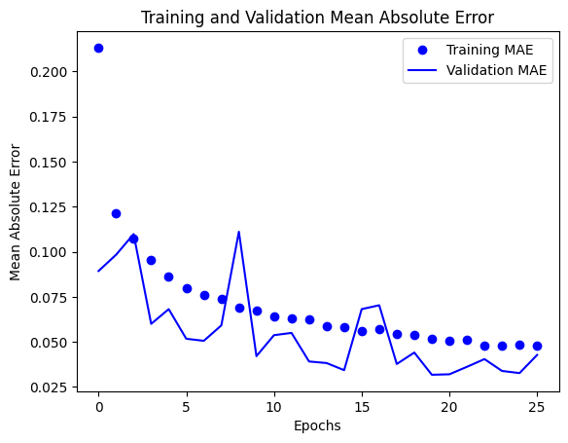

52/52 [==============================] - 0s 2ms/step - loss: 0.0034 - mae: 0.0444

Final Evaluation on Test Data

Loss: 0.0033579152077436447

Mae: 0.04438683018088341

149/149 [==============================] - 1s 2ms/step

50/50 [==============================] - 0s 2ms/step

Training RRMSE: 0.008052047151203539

Validation RRMSE: 0.013235574240305664

**Iteration 7**

Metrics Averaged

===========================

Avg Loss: 0.020351037649171694

Avg Mae: 0.06837389352066177

Avg Val_Loss: 0.007610749869075205

Avg Val_Mae: 0.051483439946813245

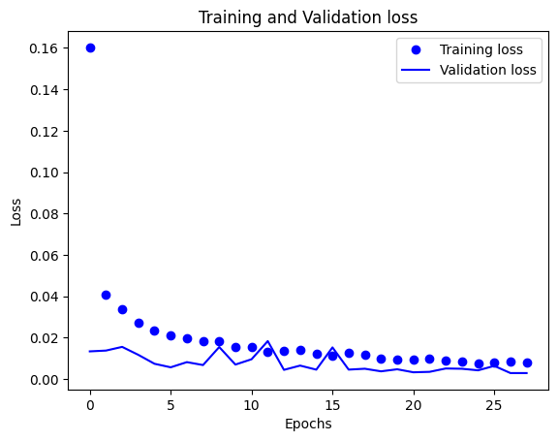

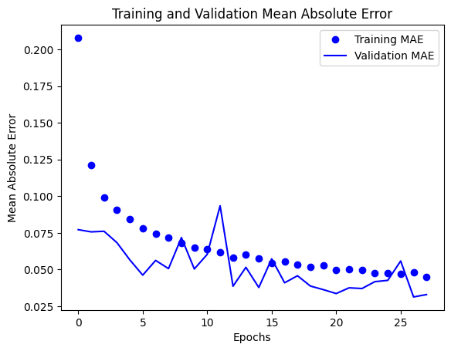

52/52 [==============================] - 0s 3ms/step - loss: 0.0024 - mae: 0.0335

Final Evaluation on Test Data

Loss: 0.0024180293548852205

Mae: 0.03345354273915291

149/149 [==============================] - 1s 3ms/step

50/50 [==============================] - 0s 2ms/step

Training RRMSE: 0.007525097034999631

Validation RRMSE: 0.010427886657154582

**Iteration 8**

Metrics Averaged

===========================

Avg Loss: 0.015079880730532434

Avg Mae: 0.05737737234195937

Avg Val_Loss: 0.009266073623186221

Avg Val_Mae: 0.046647478016498295

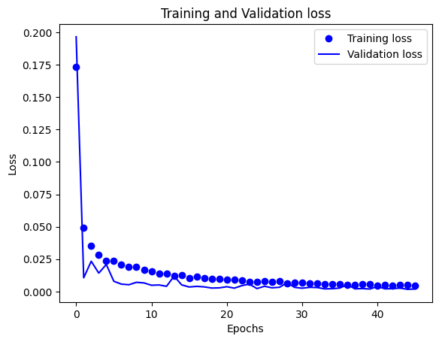

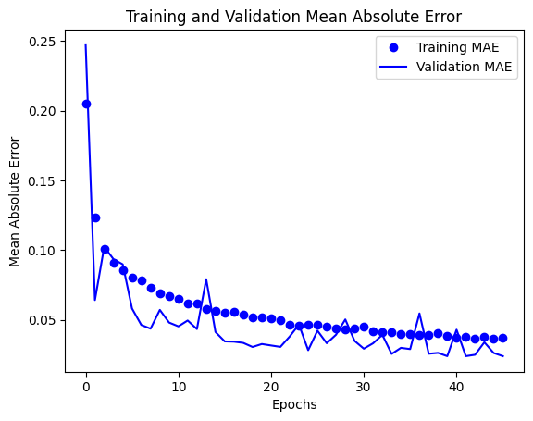

52/52 [==============================] - 0s 2ms/step - loss: 0.0016 - mae: 0.0242

Final Evaluation on Test Data

Loss: 0.0015657644253224134

Mae: 0.02421524189412594

149/149 [==============================] - 1s 2ms/step

50/50 [==============================] - 0s 2ms/step

Training RRMSE: 0.006920368065691269

Validation RRMSE: 0.00864894554400733

**Iteration 9**

Metrics Averaged

===========================

Avg Loss: 0.017955791506478015

Avg Mae: 0.06539663080783452

Avg Val_Loss: 0.007522484602625756

Avg Val_Mae: 0.05194258054389673

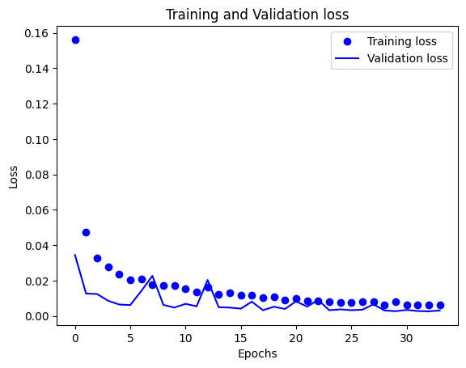

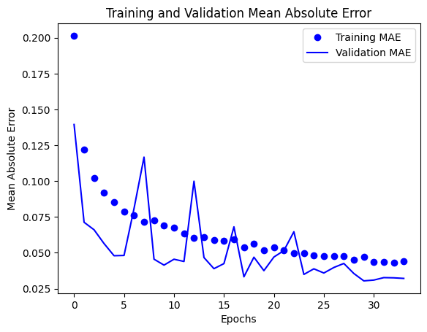

52/52 [==============================] - 0s 2ms/step - loss: 0.0024 - mae: 0.0332

Final Evaluation on Test Data

Loss: 0.002415608847513795

Mae: 0.033160753548145294

149/149 [==============================] - 1s 2ms/step

50/50 [==============================] - 0s 2ms/step

Training RRMSE: 0.012348128534075964

Validation RRMSE: 0.01088756855898934

**Iteration 10**

Metrics Averaged

===========================

Avg Loss: 0.0354444186668843

Avg Mae: 0.09089047865321238

Avg Val_Loss: 0.018163863530692954

Avg Val_Mae: 0.07197038208444913

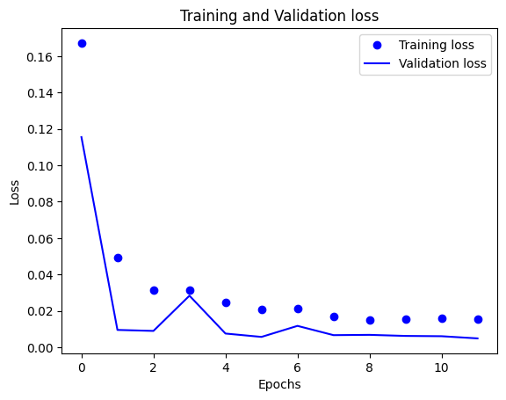

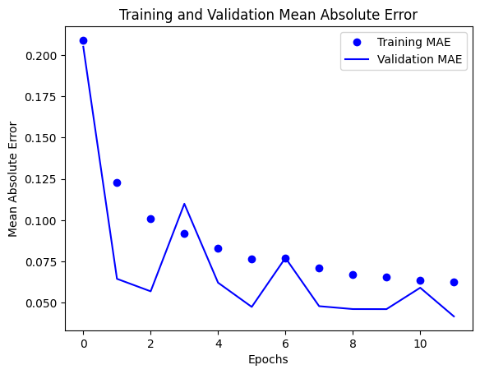

52/52 [==============================] - 0s 2ms/step - loss: 0.0037 - mae: 0.0420

Final Evaluation on Test Data

Loss: 0.0036706675309687853

Mae: 0.04203948751091957

149/149 [==============================] - 1s 2ms/step

50/50 [==============================] - 0s 2ms/step

Training RRMSE: 0.015059179170553

Validation RRMSE: 0.013677358768028674

AVG LOSS: 0.0227774456654507

AVG MAE: 0.0718167441872278

AVG VAL LOSS: 0.0095597036335214

AVG VAL MAE: 0.0561007962618584

AVG TEST LOSS: 0.0028268717062537

AVG TEST MAE: 0.0350402575004746

AVG TRAINING RRMSE: 0.09001287632

AVG VALIDATION RRMSE: 0.01120627675

0.03993676716583185

0.04218181674083466

0.051211240453902414

0.041892253003176234

0.03768010427798682

0.041349842740404485

0.04052460233233973

0.036008905973276904

0.04164974526240316

0.06151600547675116

0.04717784309